**Task 1**

**Host U can communicate with VPN Server.**

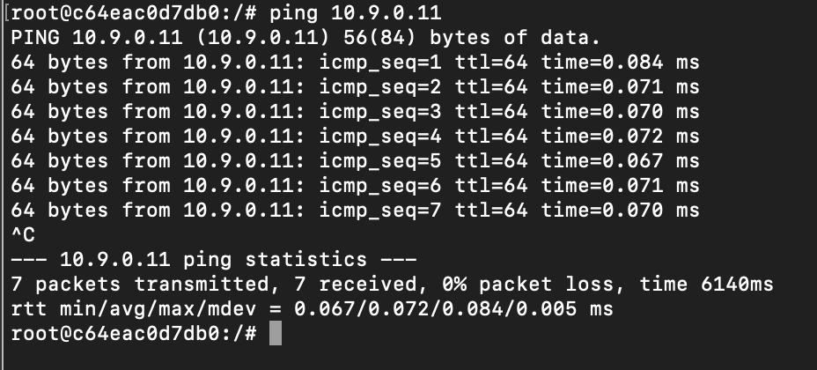**VPN Server can communicate with Host V**

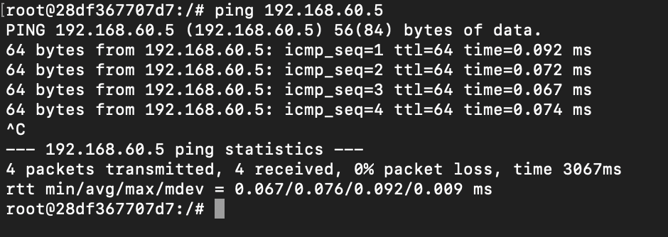**Host U should not be able to communicate with Host V**

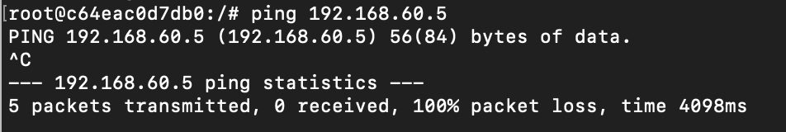

**Run tcpdump on the router, and sniff the traffic on each of the network. Show that you can capture packets**

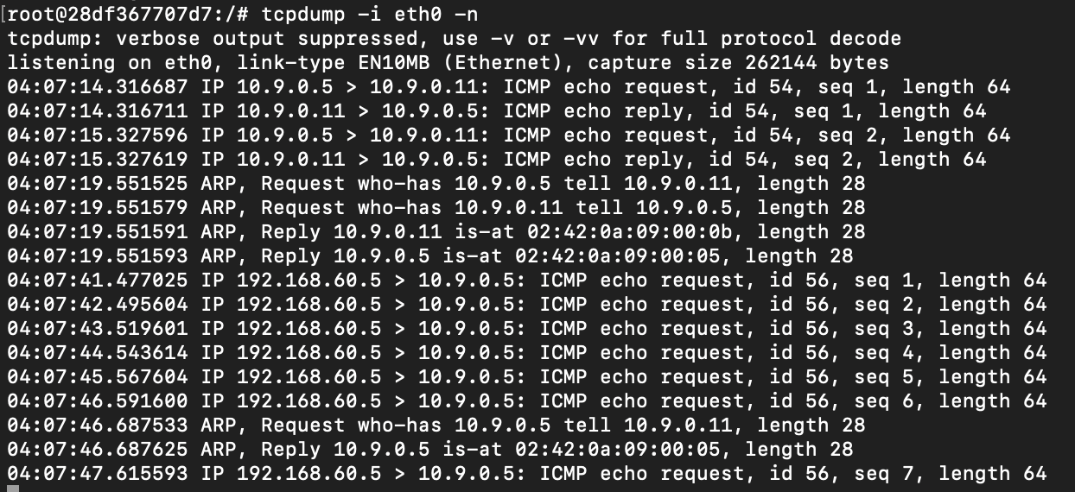

**Task 2.a**

**Code:**

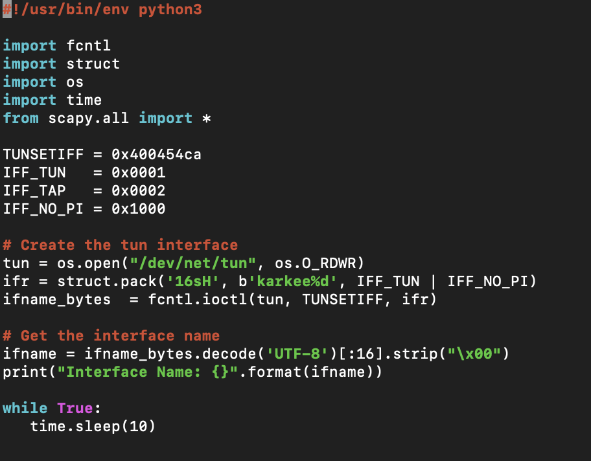

**Result**

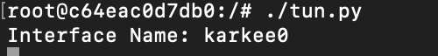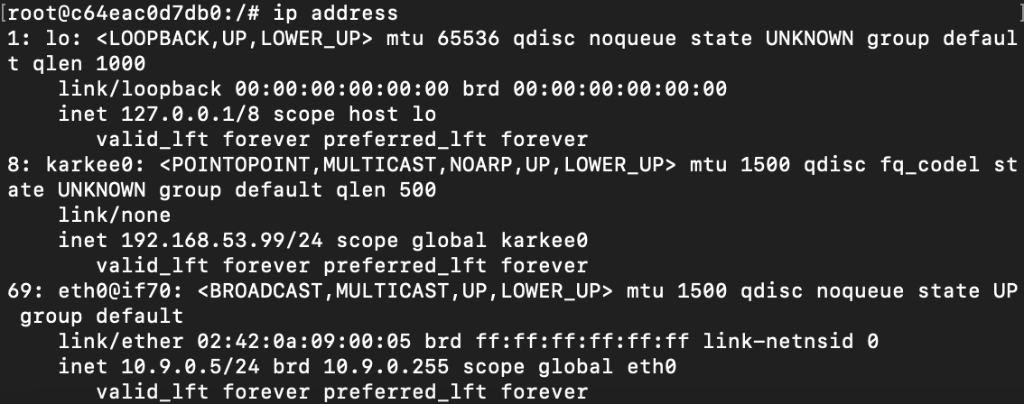

**Task 2.b**

**Code:**

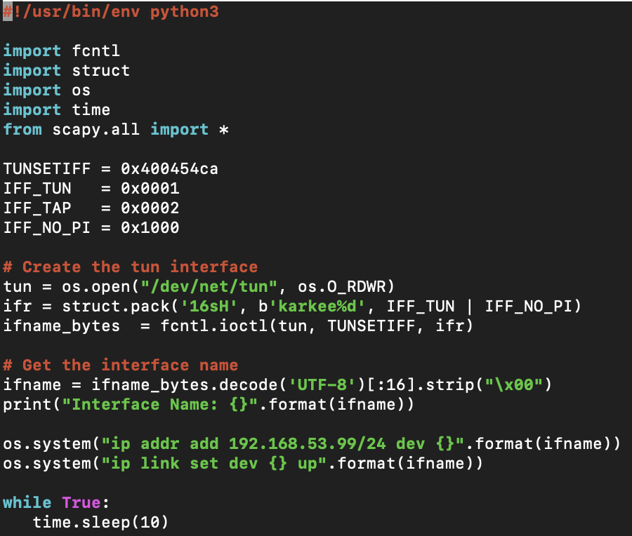

**Result:**

**Task 2.c**

**Code:**

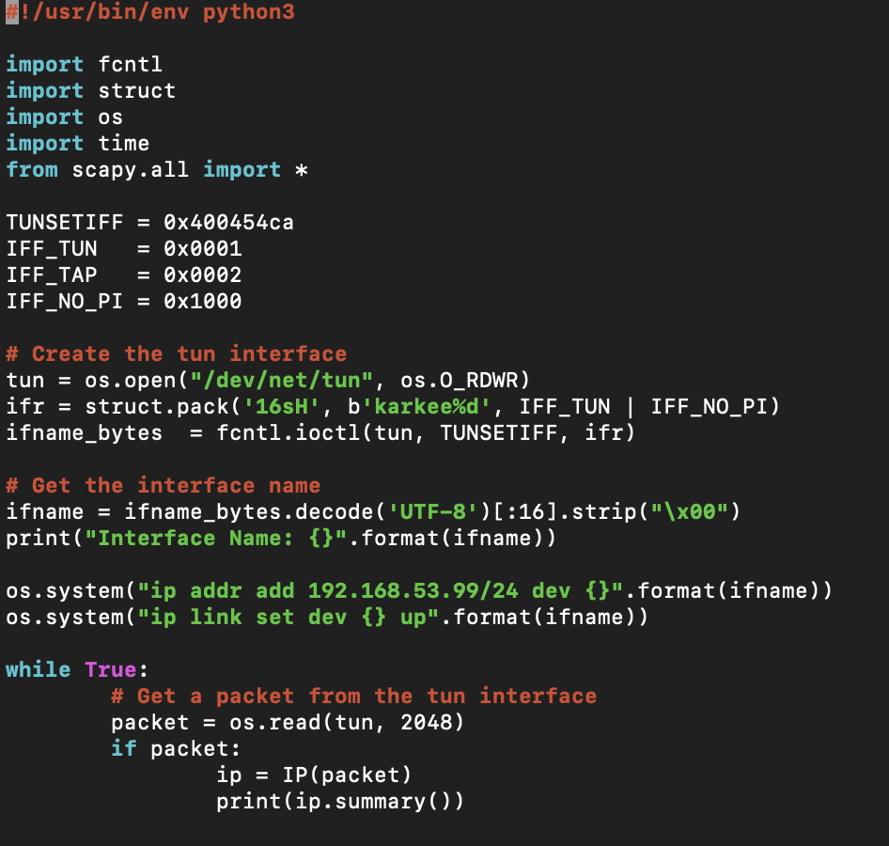

When I ping 192.168.53.3 I get the result in tun.py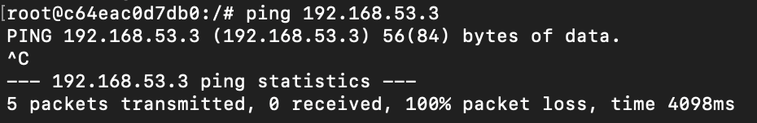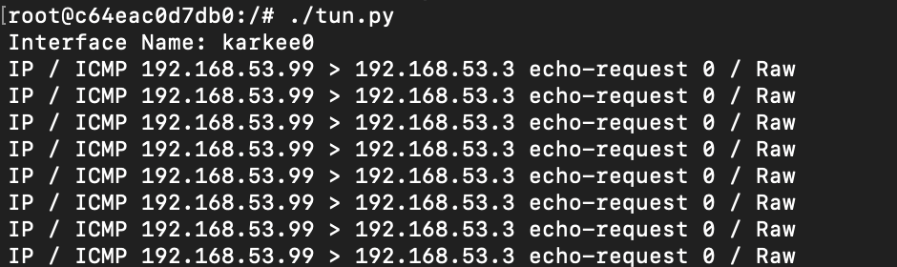But not for 192.168.60.5 as there is no connection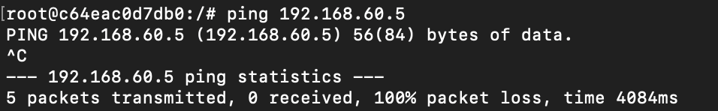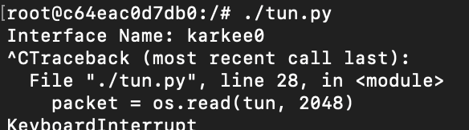

**Task 2.d**

**Code:**

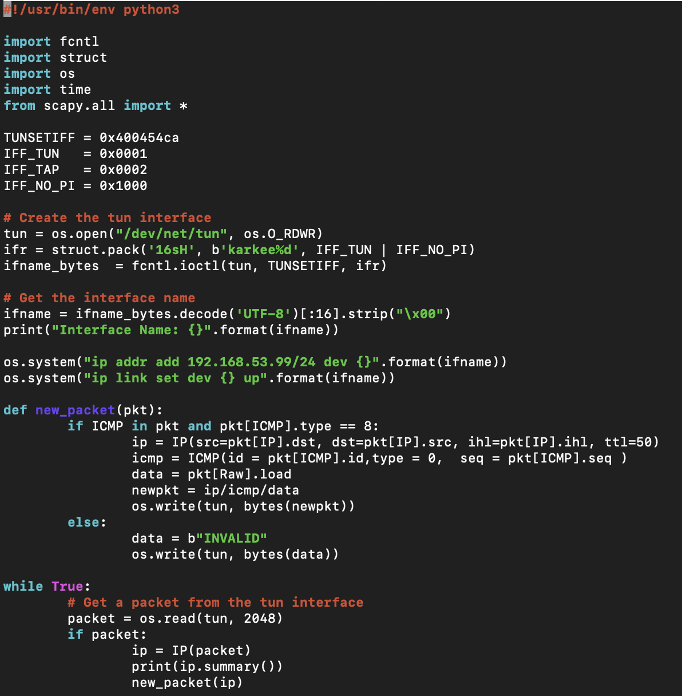

As you can see we created reply icmp packet for the ping request in above code and we are getting reply back with ttl of 50.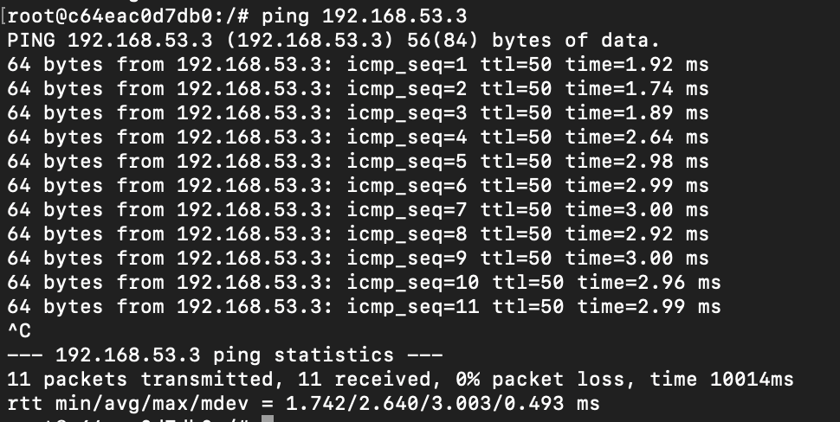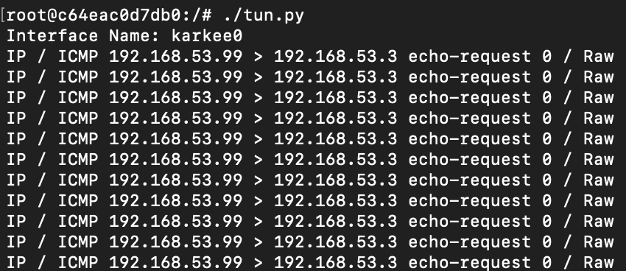We can see TCPdump reply request sequence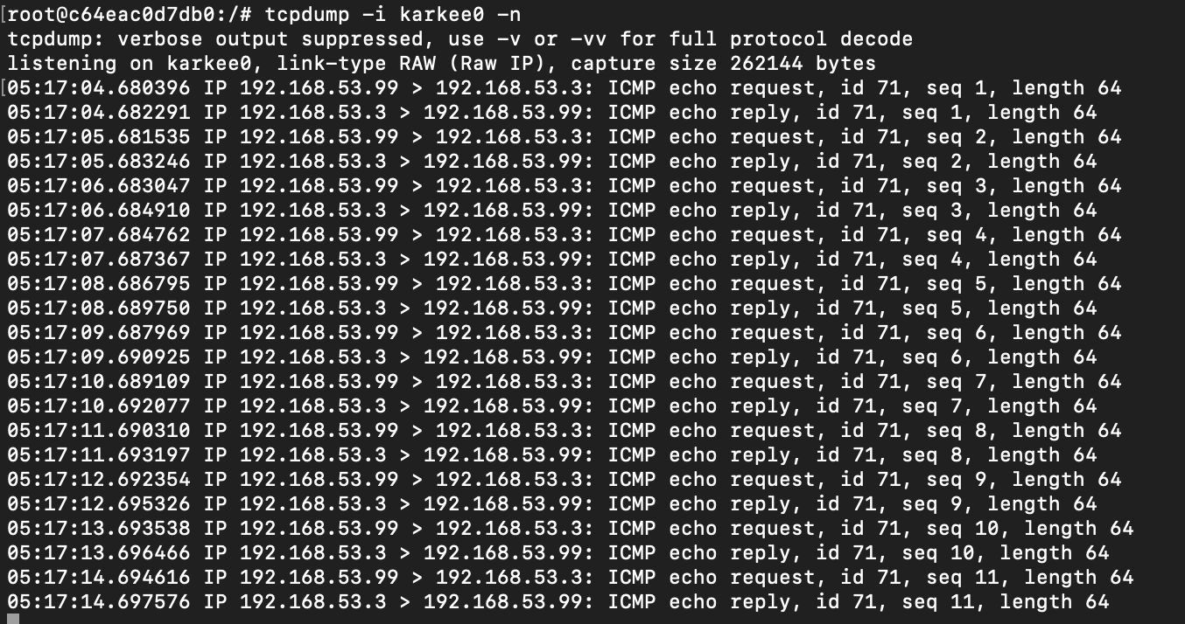

As any packet except ICMP is not properly replied back we see the result as below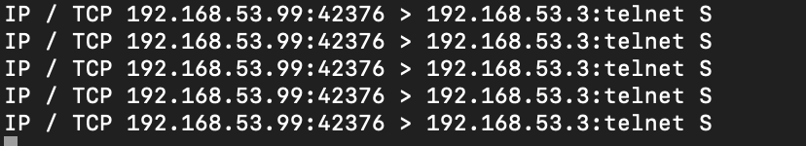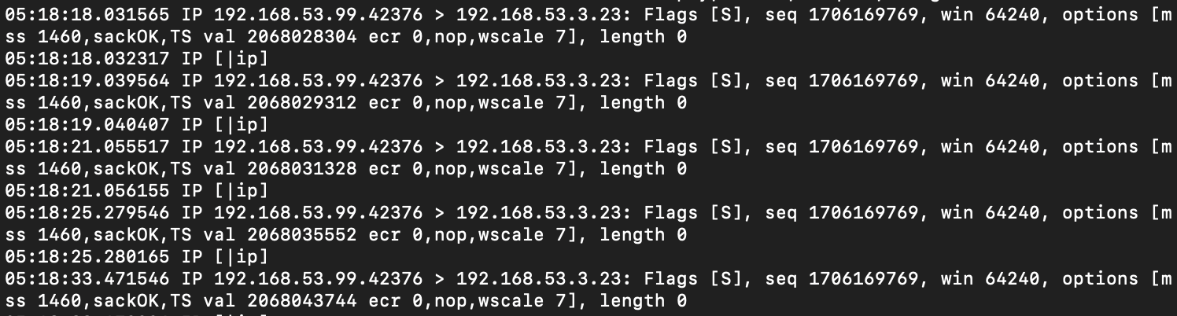

**Task 3**

**Server:**

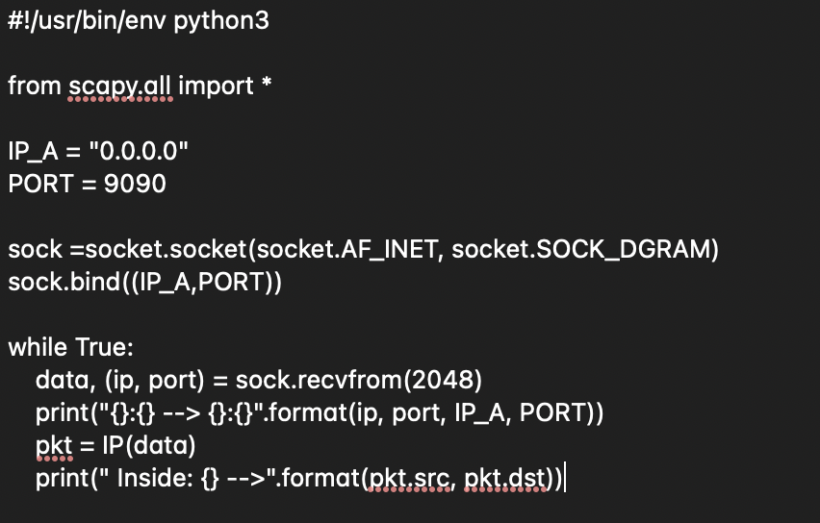

**Client:**

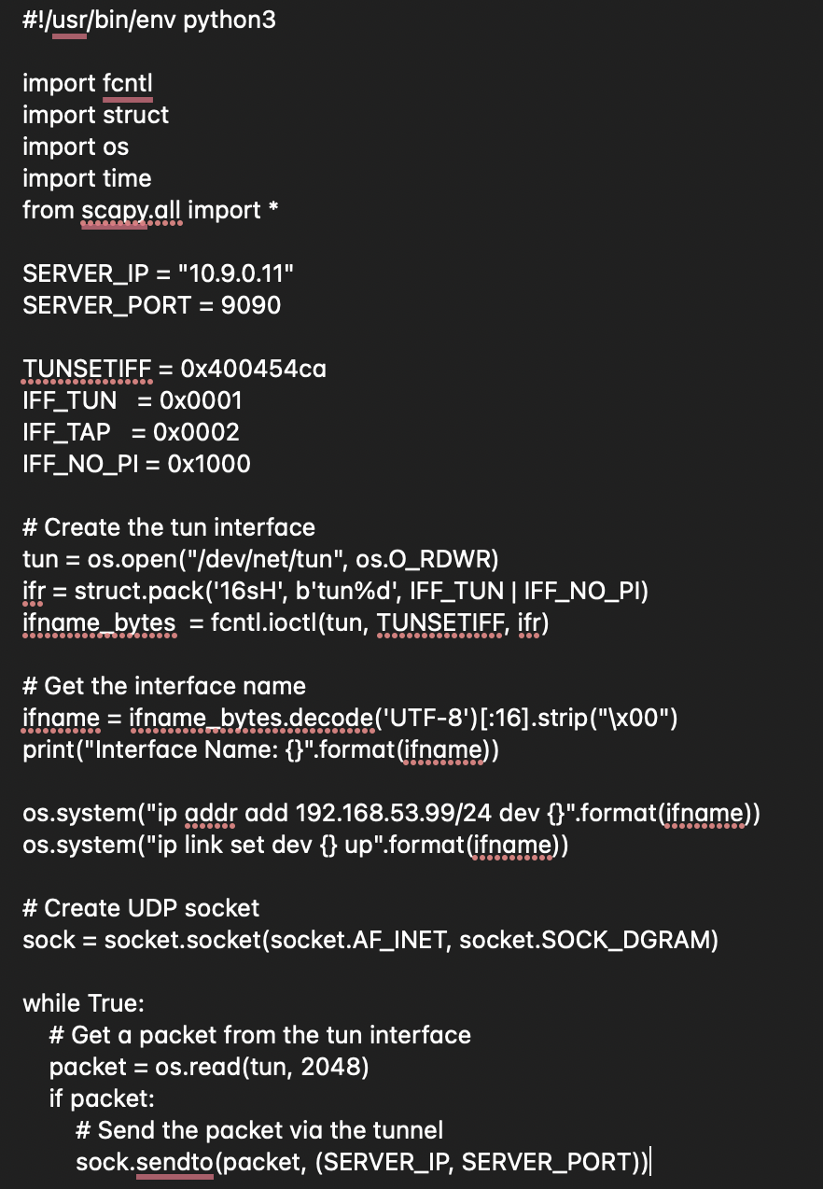

And on Host U, I pinged 192.168.53.4 to check what happened.

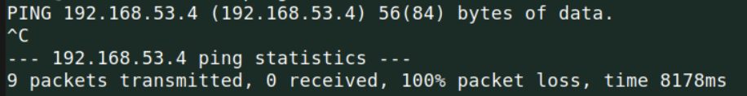No response in client.****Server code result: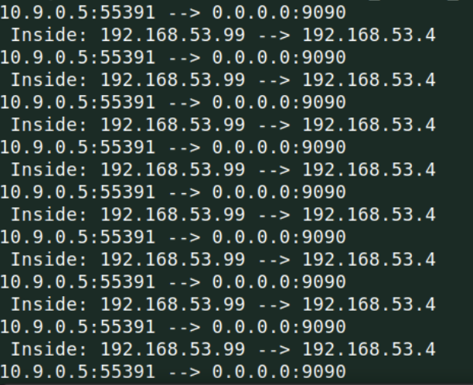If we ping to 192.168.60.5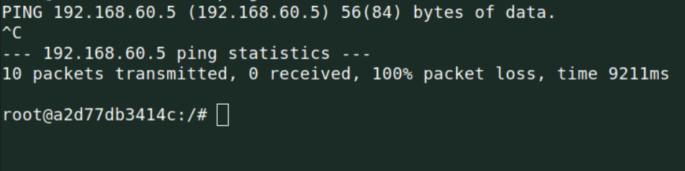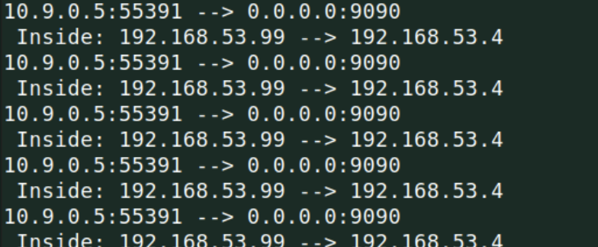It is not working so I have to add new line below in client code:****The below result shows we are getting there.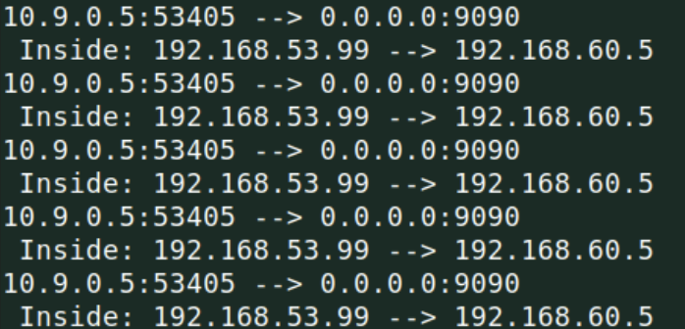

**Task 4**

In this task I have to route the packet from kernel to final destination

**Server code ran on server:  
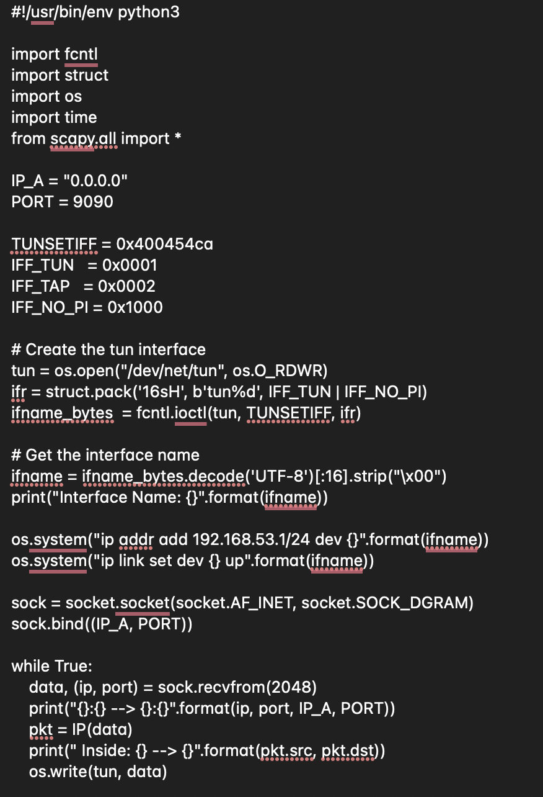**

Server code response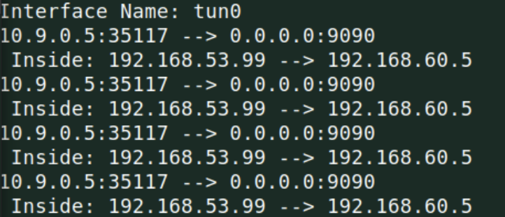Tcpdump information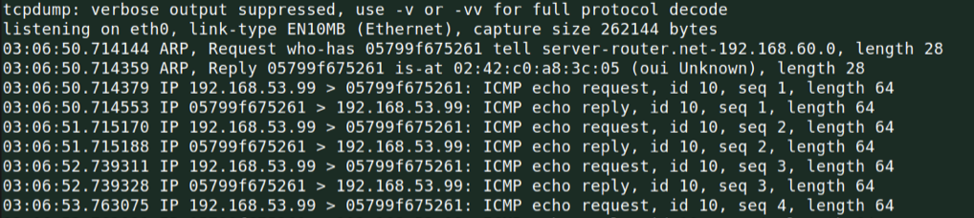

**Task 5**

**Server:  
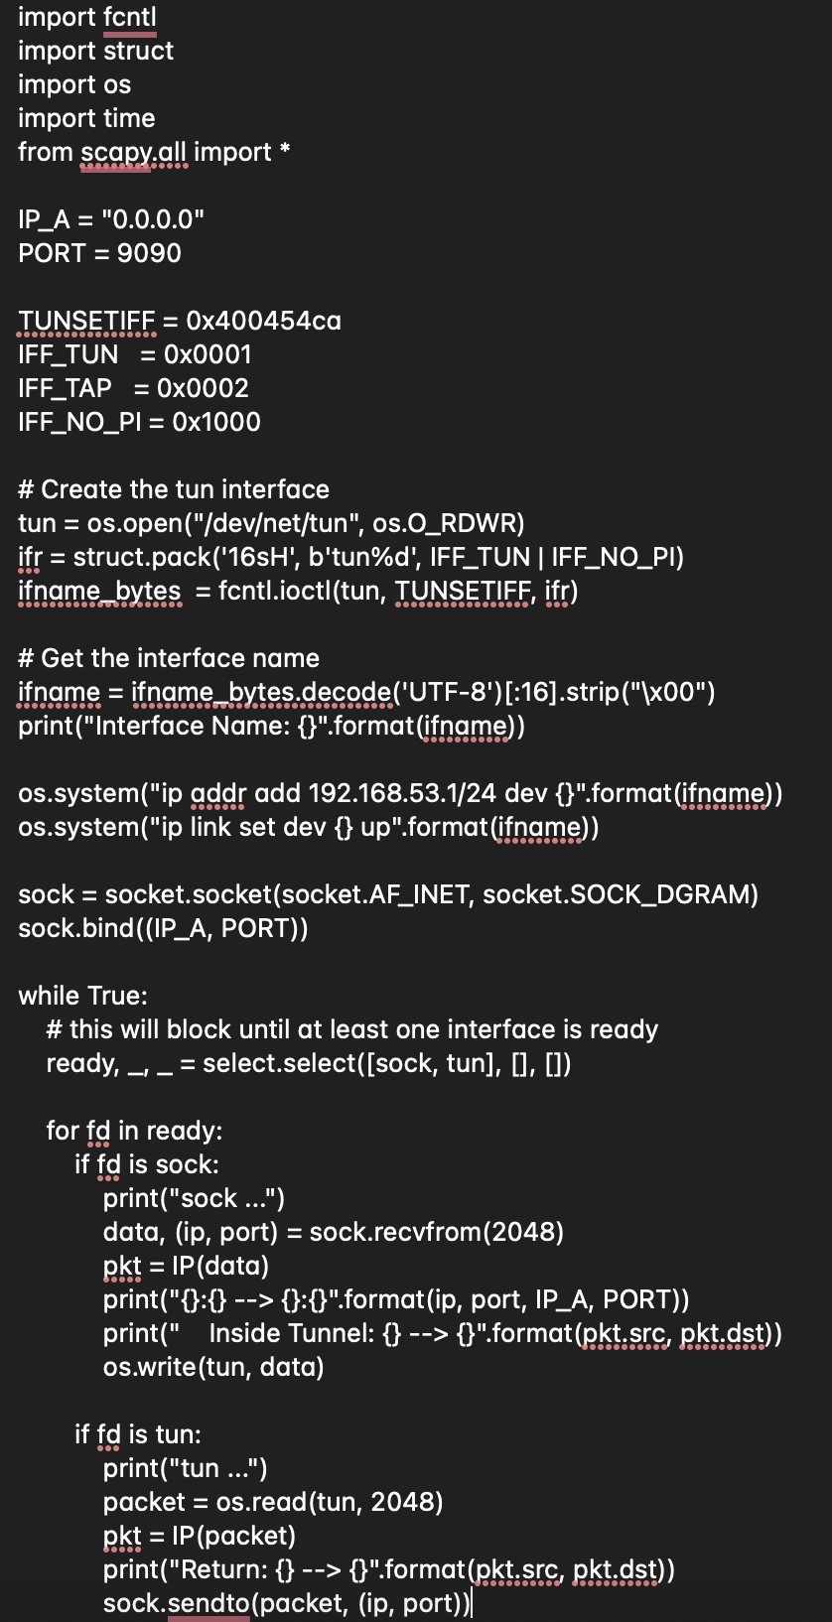**

**Client:  
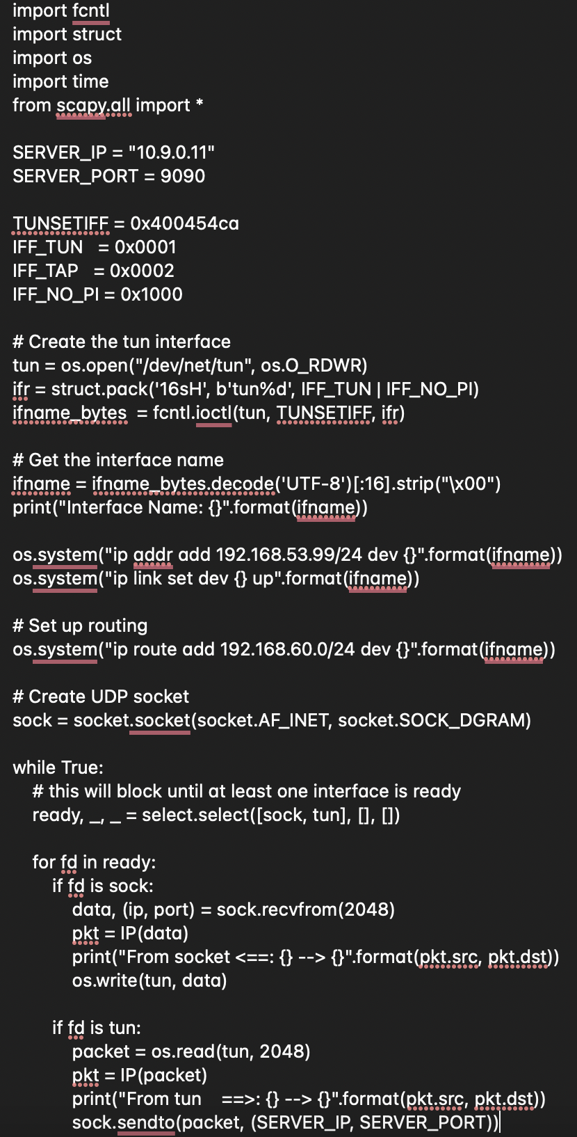**

I ran the codes in host U and these are the observation on server side with destination to host V

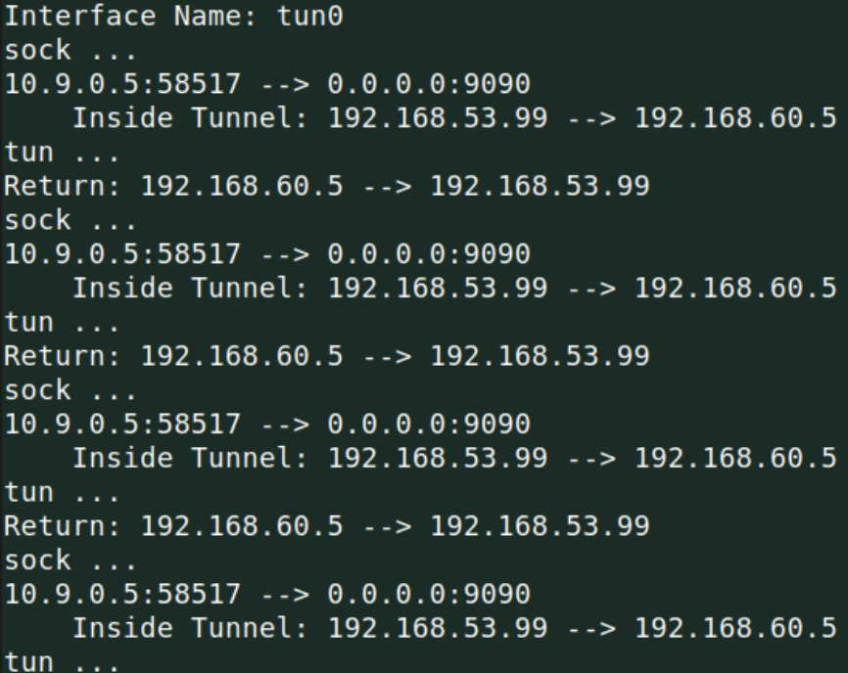

**For telnet:**

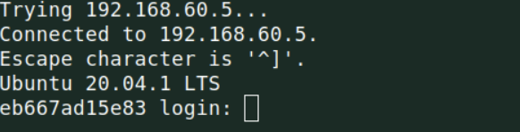

Client code response(We can see everything working)

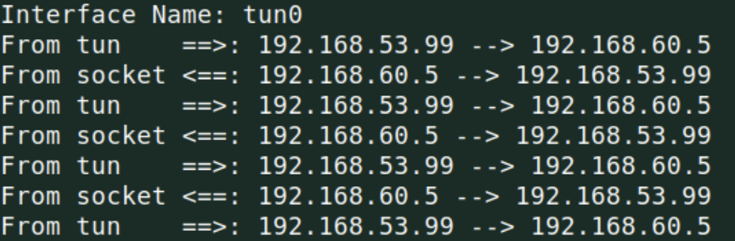

**Task 6**

First I ran this using telnet

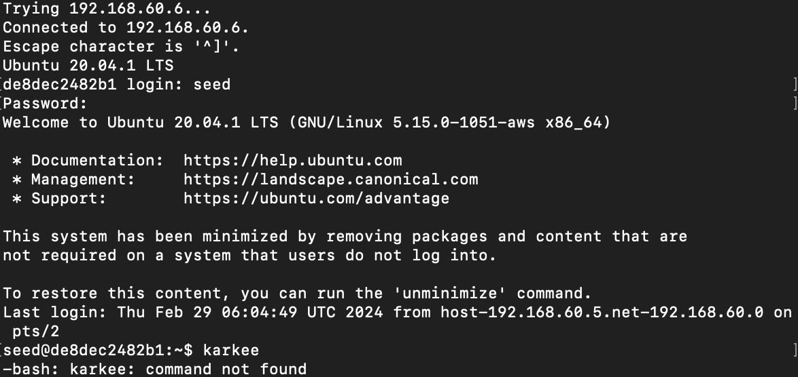

Then I stopped the server code

I typed commands after the server code stopped. I got them when I resumed the code

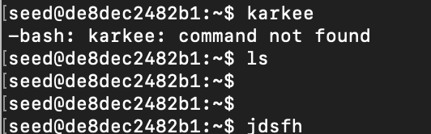

**Task 7**

Adding new route after deleting the default

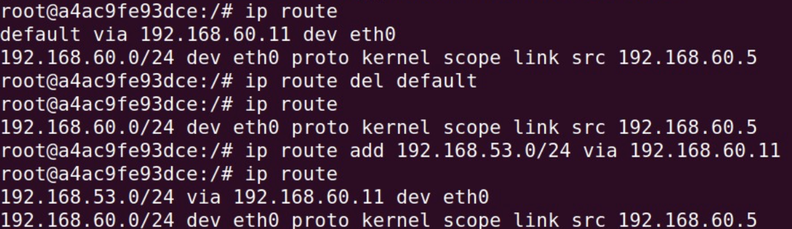

After running server code i pinged 192.168.60.5 from U and these are the result on client and server codes

**Client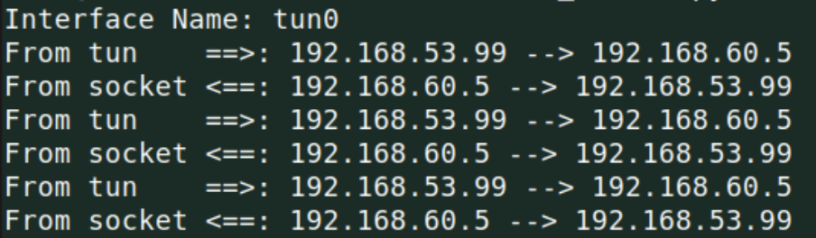Server**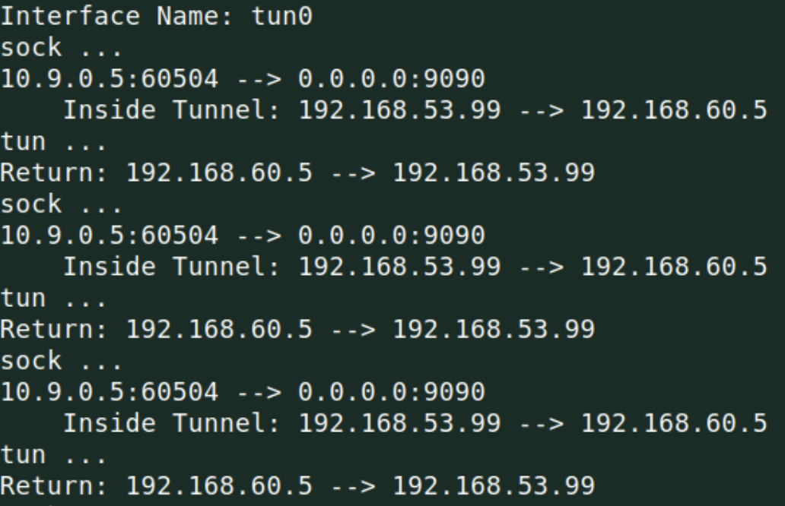

So, I was able to ping host V from U.